Asymmetrical Balance - This page uses a 3 column format to create a neatly organized asymmetrical layout. The two columns of text are balanced by the blocks of color in the lower left topped by a large block of white space. In this case, because the white space is in a block shaped much like the text columns, it becomes an element of the design in its own right.
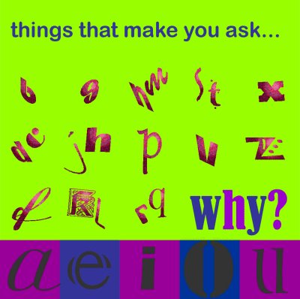
Asymmetrical/All Over Balance - It can't be neatly sliced in half like a symmetrical design but most of the elements have only small differences in shape and mass. This page achieves an overall balance by use of an underlying grid that spreads the many pieces out over the entire page, more or less evenly.
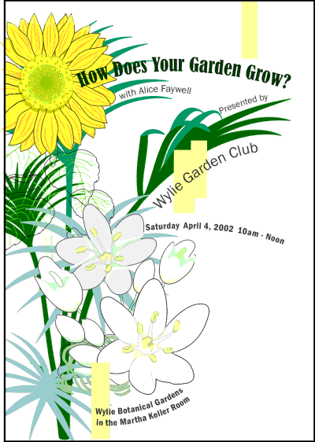
Asymmetrical Tension - Like a wild, unruly garden, the elements of this brochure cover are barely contained on the page. The plants spring up primarily along the left side but with a few stems escaping and arching across the page. The text, although randomly placed, follows the lines of the plants keeping them anchored to the overall design. The off-balance design creates a sense of freedom and movement

25 examples of symmetry in web design
Graphic Design, Inspiration, Web Design | Jul 13, 2011 | 13 comments
Tweet
inShare148
Symmetry is an age-old device of the visual artist. The word refers to two halves that perfectly mirror each other. In design, symmetry is closely tied to balance. A perfectly symmetrical design achieves balance and a sense of stability.
There is also asymmetrical design, where the two halves are balanced but do not mirror each other perfectly. The majority of websites have an asymmetrical layout.
Most often we find the logo in the top left, balanced by some navigational elements on the right. In the body, the side columns are usually balanced by either the main content or other columns.
While perfect symmetry is certainly not new to the web, it is gaining momentum. Expanding screen sizes and the proliferation of platforms and viewing options are making it a more attractive option. By mirroring the halves of a design, you not only get a greater sense of balance, but also improve the flow from top to bottom.

Icora

Icora is a perfect example of how symmetry contributes to the vertical flow of a website. I love how a story is being told here. Instead of throwing a bunch of stuff on the page and letting the user choose where to go, the designer encourages the user to scroll through the content. The designer takes you on a set journey in what is essentially a carefu

